

|  |  |
| --- | --- |
| Submitted By  Name: Muhammad Mehedi Hasan  ID: 23201143  Sec: C | Submitted To  Fahad Ahmed  Assistant Professor  Department of Computer Science and Engineering, [University of Asia Pacific](https://uap-bd.edu/) |

1. Write a C program to find the largest element in an array of integers.

Code:

#include <stdio.h>

int main() {

int n, i, max;

printf("Enter the number of elements: ");

scanf("%d", &n);

int arr[n];

printf("Enter the elements: ");

for (i = 0; i < n; i++) {

scanf("%d", &arr[i]);

}

max = arr[0];

for (i = 1; i < n; i++) {

if (arr[i] > max) {

max = arr[i];

}

}

printf("The largest element is: %d\n", max);

return 0;

}

Output:

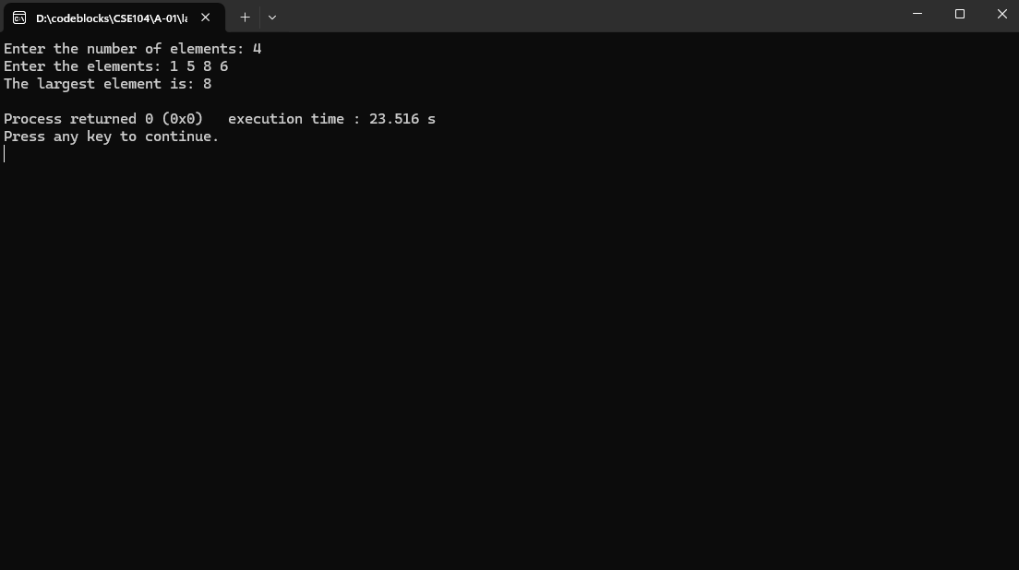

2.    Write a program to find and print the frequency of each element in an array.

Code:

#include <stdio.h>

int main() {

int n, i, j, count;

printf("Enter the number of elements: ");

scanf("%d", &n);

int arr[n], freq[n];

printf("Enter the elements: ");

for (i = 0; i < n; i++) {

scanf("%d", &arr[i]);

freq[i] = -1;

}

for (i = 0; i < n; i++) {

count = 1;

for (j = i + 1; j < n; j++) {

if (arr[i] == arr[j]) {

count++;

freq[j] = 0;

}

}

if (freq[i] != 0) {

freq[i] = count;

}

}

printf("Element\tFrequency\n");

for (i = 0; i < n; i++) {

if (freq[i] != 0) {

printf("%d\t%d\n", arr[i], freq[i]);

}

}

return 0;

}

Output:

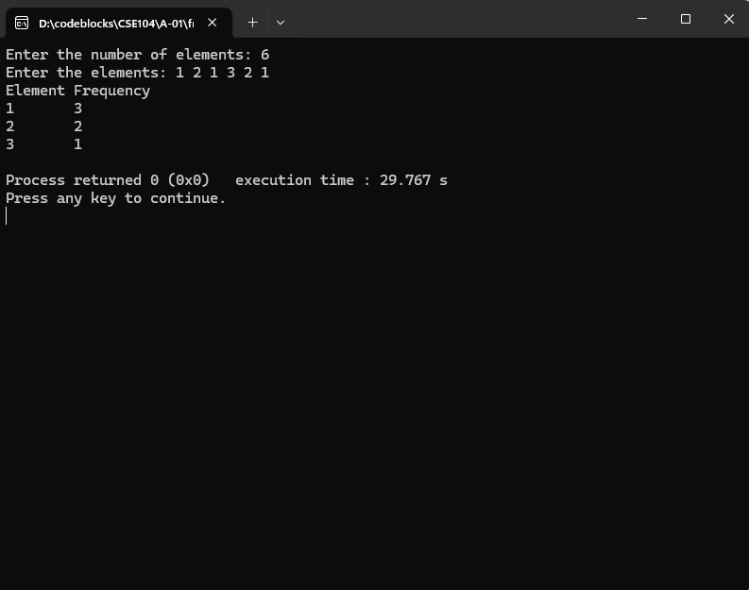

3.    Write a C program to remove duplicate elements from an array.

Code:

#include <stdio.h>

int main() {

int n, i, j, k;

printf("Enter the number of elements: ");

scanf("%d", &n);

int arr[n];

printf("Enter the elements: ");

for (i = 0; i < n; i++) {

scanf("%d", &arr[i]);

}

for (i = 0; i < n; i++) {

for (j = i + 1; j < n; j++) {

if (arr[i] == arr[j]) {

for (k = j; k < n - 1; k++) {

arr[k] = arr[k + 1];

}

n--;

j--;

}

}

}

printf("Array after removing duplicates: ");

for (i = 0; i < n; i++) {

printf("%d ", arr[i]);

}

return 0;

}

Output:



4.    Write a program to sort an array of integers in ascending or descending order

Code:

#include <stdio.h>

int main() {

int n, i, j, temp, choice;

printf("Enter the number of elements: ");

scanf("%d", &n);

int arr[n];

printf("Enter the elements: ");

for (i = 0; i < n; i++) {

scanf("%d", &arr[i]);

}

printf("Enter 1 for ascending order or 2 for descending order: ");

scanf("%d", &choice);

for (i = 0; i < n - 1; i++) {

for (j = i + 1; j < n; j++) {

if ((choice == 1 && arr[i] > arr[j]) || (choice == 2 && arr[i] < arr[j])) {

temp = arr[i];

arr[i] = arr[j];

arr[j] = temp;

}

}

}

printf("Sorted array: ");

for (i = 0; i < n; i++) {

printf("%d ", arr[i]);

}

return 0;

}

Output:



5.    Write a C program to merge two arrays into one sorted array.

Code:

#include <stdio.h>

int main() {

int n1, n2, i, j, k;

printf("Enter the number of elements in the first array: ");

scanf("%d", &n1);

int arr1[n1];

printf("Enter the elements of the first array: ");

for (i = 0; i < n1; i++) {

scanf("%d", &arr1[i]);

}

printf("Enter the number of elements in the second array: ");

scanf("%d", &n2);

int arr2[n2];

printf("Enter the elements of the second array: ");

for (i = 0; i < n2; i++) {

scanf("%d", &arr2[i]);

}

int merged[n1 + n2];

i = j = k = 0;

while (i < n1 && j < n2) {

if (arr1[i] < arr2[j]) {

merged[k++] = arr1[i++];

} else {

merged[k++] = arr2[j++];

}

}

while (i < n1) {

merged[k++] = arr1[i++];

}

while (j < n2) {

merged[k++] = arr2[j++];

}

printf("Merged sorted array: ");

for (i = 0; i < n1 + n2; i++) {

printf("%d ", merged[i]);

}

return 0;

}

Output:



6.    Write a C program to find all pairs of elements in an array whose sum equals a given number.

Code:

#include<stdio.h>

int main(){

int n,s,i,j;

scanf("%d",&s);

scanf("%d",&n);

int a[n];

printf("give the element of array ");

for(int i=0;i<n;i++){

scanf("%d",&a[i]);

}

for(int i=0;i<n;i++){

for(int j=i+1;j<n;j++){

if(a[i]+a[j]==s){

printf("%d %d ",a[i],a[j]);

}

break;

}

printf("\n");

}

return 0;

}

Output



7.    Create a program to calculate the sum of diagonal elements of a square matrix.

Code:

#include <stdio.h>

int main() {

int n, i, j, sum = 0;

printf("Enter the size of the matrix: ");

scanf("%d", &n);

int matrix[n][n];

printf("Enter the elements of the matrix:\n");

for (i = 0; i < n; i++) {

for (j = 0; j < n; j++) {

scanf("%d", &matrix[i][j]);

}

}

for (i = 0; i < n; i++) {

sum += matrix[i][i];

}

printf("Sum of diagonal elements: %d\n", sum);

return 0;

}

Output:



8.    Write a C program to find the transpose of a given matrix.

Code:

#include <stdio.h>

int main() {

int rows, cols, i, j;

printf("Enter the number of rows and columns: ");

scanf("%d %d", &rows, &cols);

int matrix[rows][cols], transpose[cols][rows];

printf("Enter the elements of the matrix:\n");

for (i = 0; i < rows; i++) {

for (j = 0; j < cols; j++) {

scanf("%d", &matrix[i][j]);

}

}

for (i = 0; i < rows; i++) {

for (j = 0; j < cols; j++) {

transpose[j][i] = matrix[i][j];

}

}

printf("Transpose of the matrix:\n");

for (i = 0; i < cols; i++) {

for (j = 0; j < rows; j++) {

printf("%d ", transpose[i][j]);

}

printf("\n");

}

return 0;

}

Output:

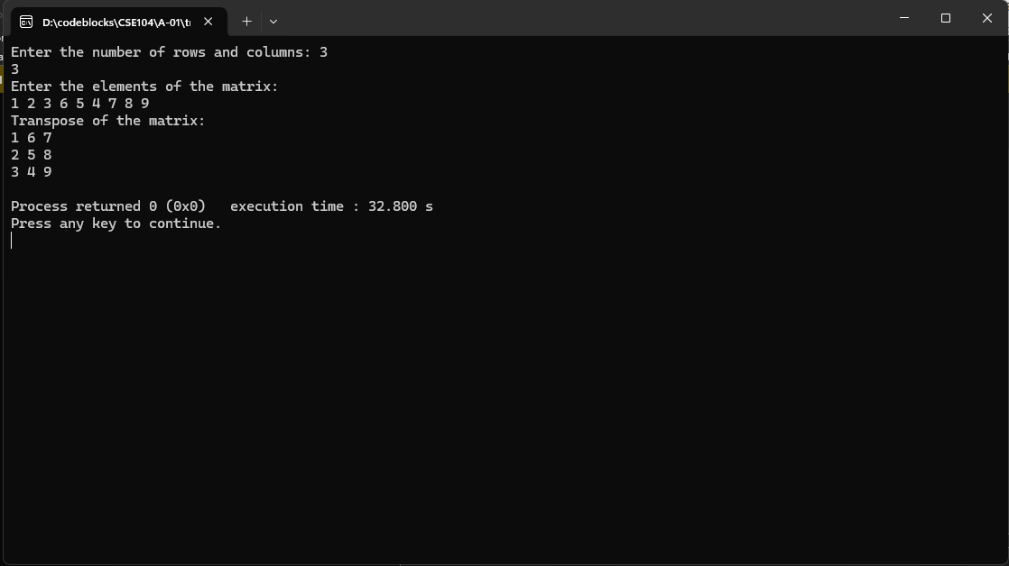

9.    Implement a program to multiply two matrices and display the result.

Code:

#include <stdio.h>

int main() {

int r1, c1, r2, c2, i, j, k;

printf("Enter rows and columns for the first matrix: ");

scanf("%d %d", &r1, &c1);

printf("Enter rows and columns for the second matrix: ");

scanf("%d %d", &r2, &c2);

if (c1 != r2) {

printf("Matrix multiplication not possible.\n");

return 0;

}

int mat1[r1][c1], mat2[r2][c2], result[r1][c2];

printf("Enter elements of the first matrix:\n");

for (i = 0; i < r1; i++) {

for (j = 0; j < c1; j++) {

scanf("%d", &mat1[i][j]);

}

}

printf("Enter elements of the second matrix:\n");

for (i = 0; i < r2; i++) {

for (j = 0; j < c2; j++) {

scanf("%d", &mat2[i][j]);

}

}

for (i = 0; i < r1; i++) {

for (j = 0; j < c2; j++) {

result[i][j] = 0;

for (k = 0; k < c1; k++) {

result[i][j] += mat1[i][k] * mat2[k][j];

}

}

}

printf("Resultant matrix:\n");

for (i = 0; i < r1; i++) {

for (j = 0; j < c2; j++) {

printf("%d ", result[i][j]);

}

printf("\n");

}

return 0;

}

Output:



10.    Write a C program to find the row in a matrix that has the maximum sum of its elements.

Code:

#include <stdio.h>

int main() {

int rows, cols, i, j, maxSum = 0, maxRow = 0;

printf("Enter the number of rows and columns: ");

scanf("%d %d", &rows, &cols);

int matrix[rows][cols];

printf("Enter the elements of the matrix:\n");

for (i = 0; i < rows; i++) {

for (j = 0; j < cols; j++) {

scanf("%d", &matrix[i][j]);

}

}

for (i = 0; i < rows; i++) {

int sum = 0;

for (j = 0; j < cols; j++) {

sum += matrix[i][j];

}

if (sum > maxSum) {

maxSum = sum;

maxRow = i;

}

}

printf("The row with the maximum sum is: %d\n", maxRow);

return 0;

}

Output:

